SEA AND OCEAN IDIOMS

Sea idioms

Learn and review these 13 common idioms with words related to the sea, ocean, sea life and sailing.

Idiom

Definition

Big fish in a small pond

If you are a big fish in a small pond, you are an important person only in a small area or organisation.

Mike thinks he is important because of his high position in the company. But he’s really just a big fish in a small pond.

Drink like a fish

If you drink like a fish, you drink too much alcohol.

Brian drinks like a fish when he goes out with his friends.

Like a fish out of water

If you feel like a fish out of water, you are very uncomfortable in the situation you are in.

Pamela felt like a fish out of water at the party. She did not feel comfortable at all.

A whale of a time

If you are having a whale of a time, you are really enjoying yourself.

We had a whale of a time at the party last night.

The world is your oyster.

If you tell someone that the world will be their oyster, you say that all opportunities are open to them and they can get everything they want from life.

When you graduate from university, theworld will be your oyster.

Keep something at bay

Prevent something from harming you

Exercise and a healthy diet can help keep fat at bay.

The coast is clear.

No one is watching

The coast is clear, you don't have to hide any more.

A drop in the ocean

A very small part of what you really need

A thousand dollars seems like a lot of money, but it's just a drop in the ocean. We need much more to start the business.

Plenty more fish in the sea

If you say that there are plenty more fish in the sea, you tell someone that there are many other people or possibilities to be found. You usually say this to make somebody feel better.

Don't worry, you will find another boyfriend soon. They're plenty more fish in the sea.

Plain sailing

smooth and easy progress

In the end, George managed to achieve his ambition. But it wasn't all plain sailing.

Rock the boat

to do or say something that will upset people or cause trouble

Everybody is happy with the decision. Try not to rock the boat.

Make waves

to shock or upset people with something new or different

She is trying to make waves on the fashion scene with her unusual taste in clothes.

Run a tight ship

to control a business or other organization firmly and effectively

The managers make sure that no penny is wasted. They run a tight ship.

SEA AND OCEAN IDIOMS

Sea idioms

Learn and review these 13 common idioms with words related to the sea, ocean, sea life and sailing.

Idiom

Definition

Big fish in a small pond

If you are a big fish in a small pond, you are an important person only in a small area or organisation.

Mike thinks he is important because of his high position in the company. But he’s really just a big fish in a small pond.

Drink like a fish

If you drink like a fish, you drink too much alcohol.

Brian drinks like a fish when he goes out with his friends.

Like a fish out of water

If you feel like a fish out of water, you are very uncomfortable in the situation you are in.

Pamela felt like a fish out of water at the party. She did not feel comfortable at all.

A whale of a time

If you are having a whale of a time, you are really enjoying yourself.

We had a whale of a time at the party last night.

The world is your oyster.

If you tell someone that the world will be their oyster, you say that all opportunities are open to them and they can get everything they want from life.

When you graduate from university, theworld will be your oyster.

Keep something at bay

Prevent something from harming you

Exercise and a healthy diet can help keep fat at bay.

The coast is clear.

No one is watching

The coast is clear, you don't have to hide any more.

A drop in the ocean

A very small part of what you really need

A thousand dollars seems like a lot of money, but it's just a drop in the ocean. We need much more to start the business.

Plenty more fish in the sea

If you say that there are plenty more fish in the sea, you tell someone that there are many other people or possibilities to be found. You usually say this to make somebody feel better.

Don't worry, you will find another boyfriend soon. They're plenty more fish in the sea.

Plain sailing

smooth and easy progress

In the end, George managed to achieve his ambition. But it wasn't all plain sailing.

Rock the boat

to do or say something that will upset people or cause trouble

Everybody is happy with the decision. Try not to rock the boat.

Make waves

to shock or upset people with something new or different

She is trying to make waves on the fashion scene with her unusual taste in clothes.

Run a tight ship

to control a business or other organization firmly and effectively

The managers make sure that no penny is wasted. They run a tight ship.

http://www.globalsecurity.org/military/library/policy/army/fm/55-501/image1444.gif

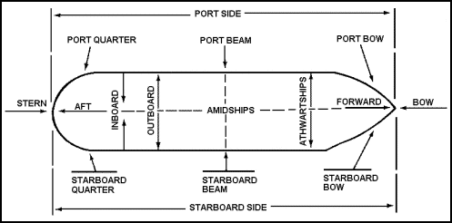

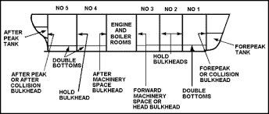

http://image.slidesharecdn.com/partsofaship-111001123845-phpapp02/95/parts-of-a-ship-2-728.jpg?cb=1317472853
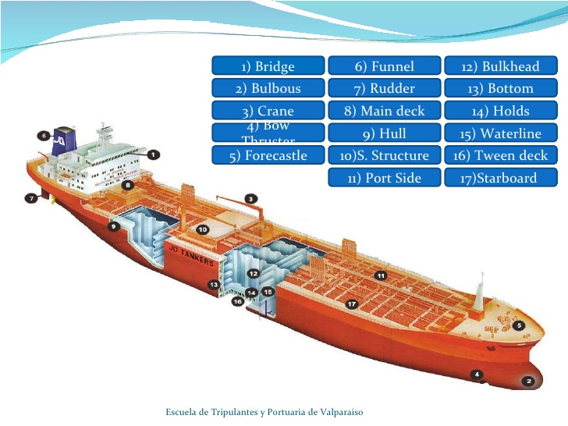

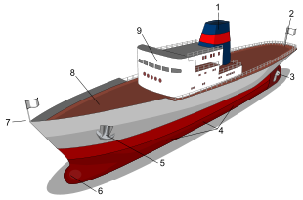
Main parts of ship. 1: Smokestack or Funnel; 2: Stern;3: Propeller and Rudder; 4: Portside (the right side is known as starboard); 5: Anchor; 6: Bulbous bow; 7: Bow;8: Deck; 9: Superstructure

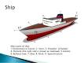

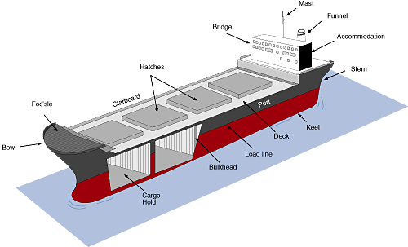

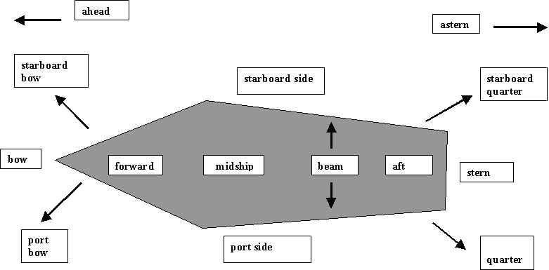

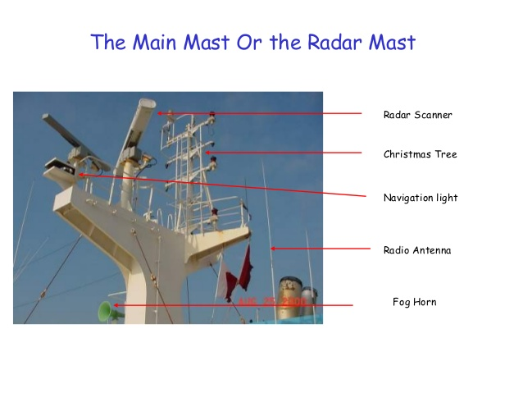
http://www.titanicstory.com/cutsmall.jpg

http://image.slidesharecdn.com/partsofaship-111001123845-phpapp02/95/parts-of-a-ship-1-728.jpg?cb=1317472853

