Learner’s Word of the Day

June 27, 2021

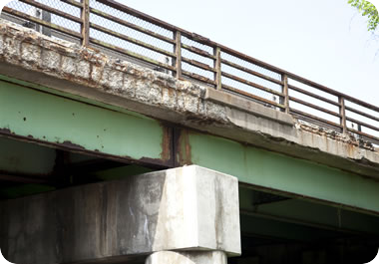

The bridge is deteriorating.

deteriorate /dɪˈtirijəˌreɪt/ verb

1 [no object] : to become worse as time passes
The weather gradually deteriorated [=worsened] as the day went on.
Her health continues to deteriorate. [=decline]
efforts to save a deteriorating rain forest
The disagreement deteriorated into a fight. [=the disagreement got worse and eventually became a fight]
2 [+ object] : to make (something) worse
Exposure to rain and sun will gradually deteriorate the paint.
— deteriorated adjective
a deteriorated [=run-down, dilapidated] building
a badly deteriorated part of the city

