Learner’s Word of the Day

June 8, 2021

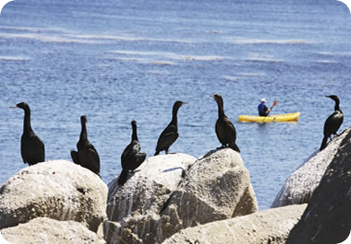

Birds perched on the rocks

perch /ˈpɚtʃ/ verb

1 [no object] : to sit on or be on something high or on something from which it is easy to fall — usually + on
Birds often perch on the ledge outside my window.
People perched on the railing to get a better view.
Their house perches on a rocky cliff.
2 [+ object] : to put (someone or something) on something high or on something from which it is easy to fall
People perched themselves on the railing [=people sat on the railing] to get a better view.
— usually used as (be) perched
He stood there in his coat, a small hat perched on/atop his head.
A bird was perched on the telephone wire.
Their house is perched on a rocky cliff.
The castle is perched high in/among the hills of Scotland.

