If this message doesn’t display properly, open in a web browser ››

Learner’s Word of the Day

May 30, 2021

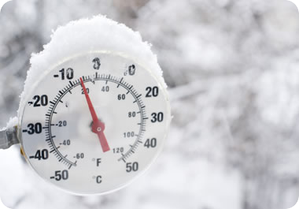

Temperatures plummeted below freezing

plummet /ˈplʌmət/ verb

[no object]
1 always followed by an adverb or preposition : to fall suddenly straight down especially from a very high place
The acrobat plummeted into the net.
The car plummeted to the bottom of the canyon.
The satellite plummeted into/toward the ocean.
2 : to fall or drop suddenly in amount, value, etc... : PLUNGE
Stock prices plummeted 40 percent during the scandal.
The TV show has plummeted in the ratings.
Temperatures are expected to plummet this weekend.
The town's population plummets when the students leave for the summer.

